Streamlining Ticket Assignment for Efficient Support Operations

Project Statement
In modern customer support environments, handling a large volume of support tickets efficiently is a major challenge. Manual or poorly structured ticket assignment often leads to delays, misrouting, agent overload, and decreased customer satisfaction.
This project aims to design and implement an intelligent and automated ticket assignment system that ensures tickets are routed to the most appropriate agents based on predefined rules such as priority, category, and skill set. The goal is to improve operational efficiency, reduce response time, and enhance overall customer experience.
Project Objectives
- Automate ticket assignment to minimize manual intervention
- Reduce response and resolution time through efficient routing
- Improve workload distribution among support agents
- Enhance first-contact resolution rate
- Implement priority-based handling for urgent issues
- Develop a scalable system adaptable to growing ticket volumes
- Monitor and optimize performance using key metrics

Skills Required
Technical Skills
- Basic understanding of Helpdesk/Ticketing Systems
- Knowledge of Workflow Automation
- Programming (optional but useful):
  - Python / JavaScript
- Database basics (SQL)
- Understanding of APIs (for integrations)
Analytical Skills
- Problem-solving
- Process analysis
- Data interpretation (KPIs like SLA, response time)
Tools & Platforms (Optional)
- Zendesk / Freshdesk / ServiceNow
- Excel / Google Sheets (for tracking & analysis)
- Workflow tools (Zapier, Power Automate)
Soft Skills
- Communication
- Logical thinking
- Attention to detail

Task Initialization (Project Execution Steps)
Phase 1: Requirement Analysis
- Identify current issues in ticket assignment
- Gather requirements from support team
- Define ticket categories and priorities
Phase 2: Create Users
- Open service now.
- Click on All >> search for users
- Select Users under system security
- Click on new
- Fill the following details to create a new user
- Click on submit
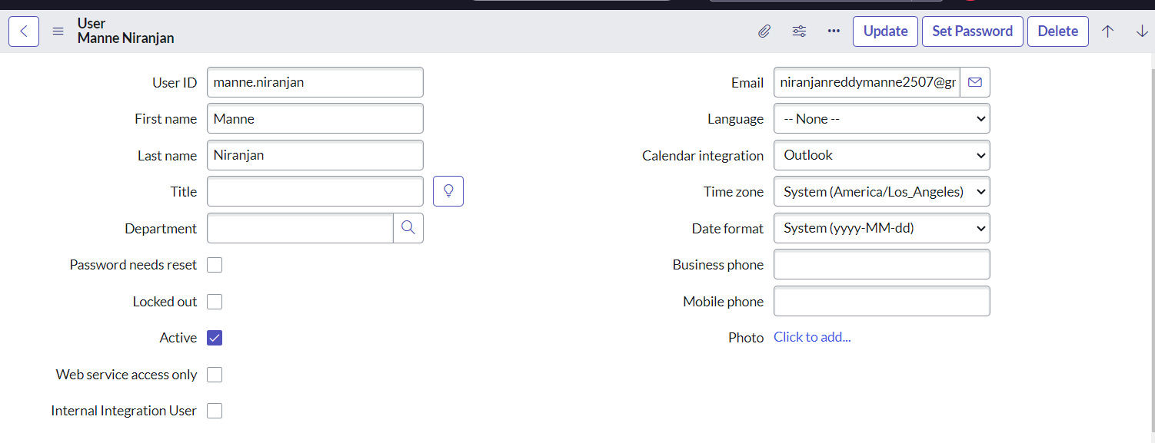
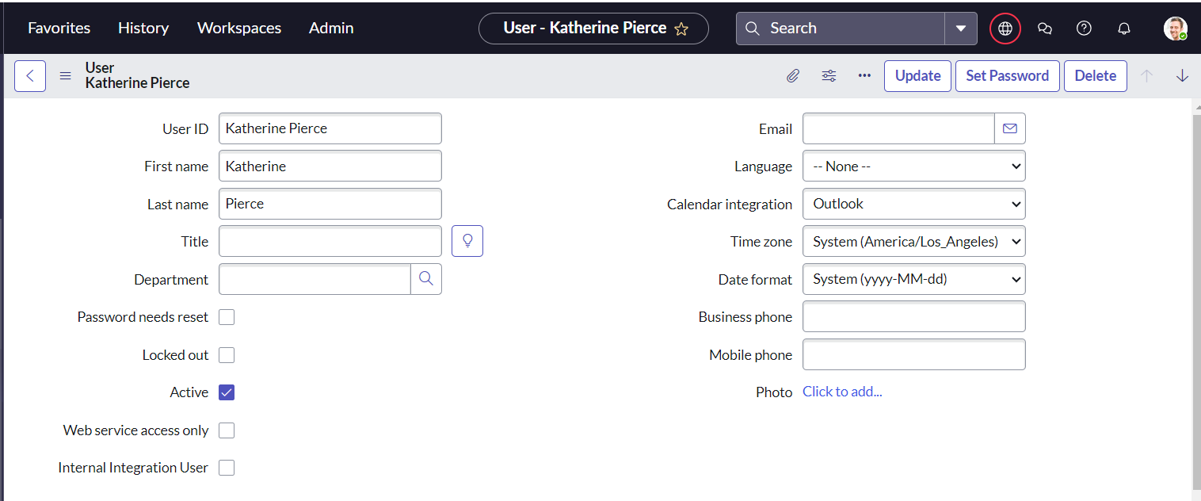
Create one more user:
- Create another user with the following details
- Click on submit
Phase 3: Groups
Two support groups are created to manage ticket assignments efficiently. The Certificates group handles certificate-related issues, while the Platform group manages platform-related problems such as login errors and access issues. These groups ensure tickets are routed to the appropriate team automatically.
Create Groups

- Open service now.
- Click on All >> search for groups
- Select groups under system security
- Click on new
- Fill the following details to create a new group
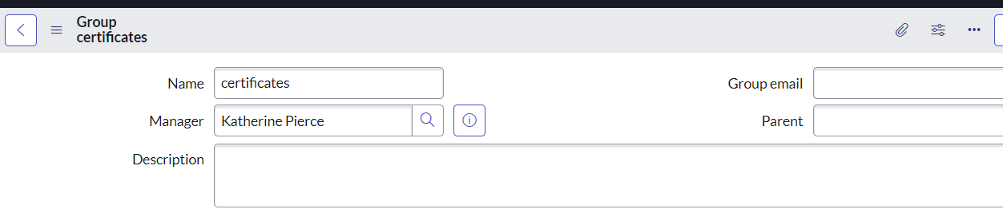

- Click on submit
- Create one more group:
- Create another group with the following details

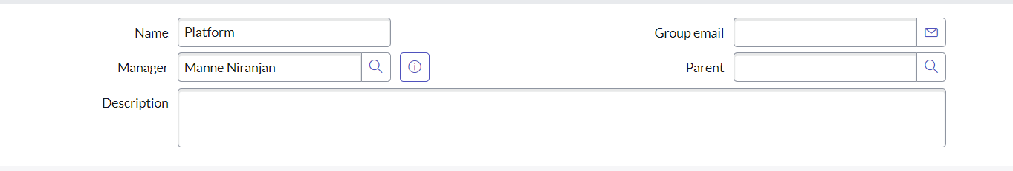
- Click on submit

Phase 4: Roles
Two custom roles are created to control access and responsibilities within the system. The Certification_role grants access to handle certificate-related tickets, while the Platform_role allows users to manage platform-related issues. These roles enforce proper access control and support automated ticket assignment.
Create roles
- Open service now.
- Click on All >> search for roles
- Select roles under system security
- Click on new
- Fill the following details to create a new role
- Click on submit
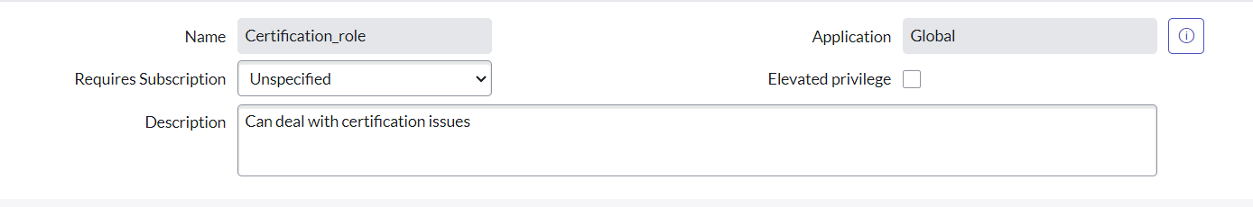

- Create one more role:
- Create another role with the following details
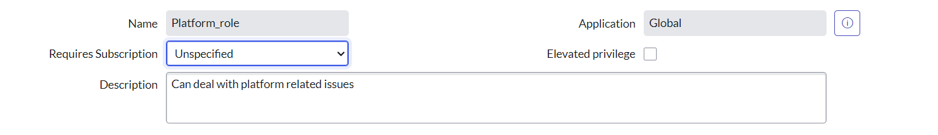
- Click on submit

Phase 5: Table

A custom table named Operations Related is created to store and manage support tickets. It includes fields such as Issue (Choice), Description, and Assignment Group to categorize and route tickets properly. This table acts as the central record for automated ticket assignment and access control.
Create Table
- Open service now.
- Click on All >> search for tables
- Select tables under system definition
- Click on new
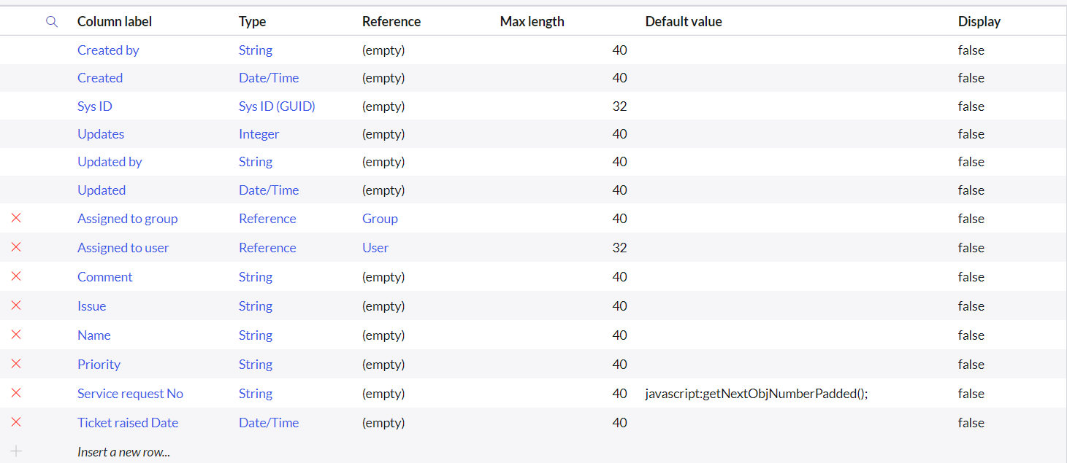
- Fill the following details to create a new table
Label : Operations related
Check the boxes Create module & Create mobile module
- Under new menu name : Operations related
- Under table columns give the columns
- Click on submit
- Create choices for the issue filed by using form design
Choices are
unable to login to platform
404 error
regarding certificates
regarding user expired

Phase 6: Assign roles & users to groups
Users and their respective roles are assigned to the appropriate support groups to establish proper ownership and access control. Katherine Pierce with the Certification_role is added to the Certificates group, while Manne Niranjan with the Platform_role is added to the Platform group. This setup ensures tickets are handled only by authorized team members.

Assign roles & users to certificate group
- Open service now.
- Click on All >> search for tables
- Select tables under system definition
- Select the certificates group
- Under group members
- Click on edit
- Select Katherine Pierce and save
- Click on roles
- Select Certification_role and save

Assign roles & users to platform group
- Open service now.
- Click on All >> search for tables
- Select tables under system definition
- Select the platform group
- Under group members
- Click on edit
- Select Manne Niranjan and save
- Click on roles
- Select Platform_role and save
Phase 7: Assign role to table
The custom roles Certification_role and Platform_role are assigned to the Operations Related table under Application Access. Both roles are granted Read and Write permissions to ensure only authorized users can access and modify records. This enforces role-based security at the table level and protects ticket data from unauthorized access.

Assign role to table
- Open ServiceNow and navigate to All → System Definition → Tables.
- Search and open the Operations Related table.
- Click on Application Access.
- Open the u_operations_related.read operation.
- Click your profile (top right) and Elevate Role → security_admin.
- Under Requires role, insert a new row and add:
- Platform_role
- Certification_role
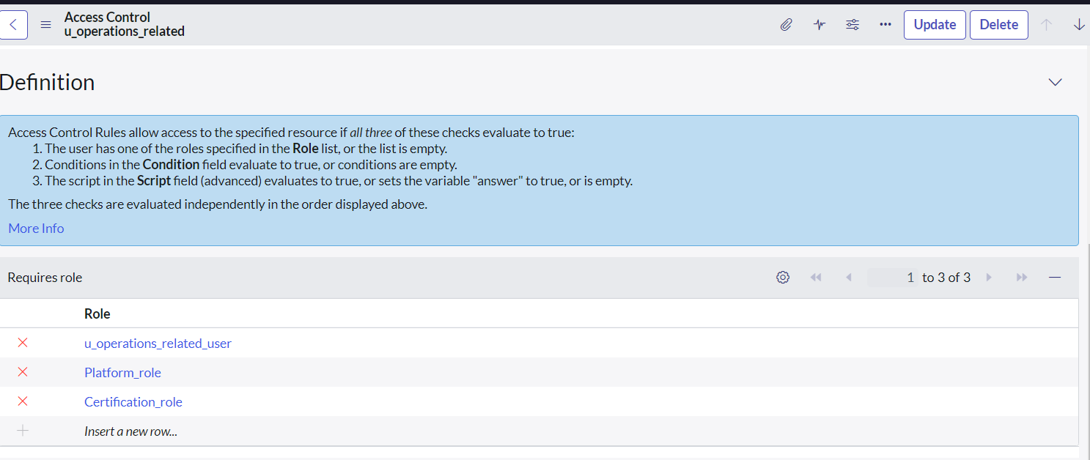
- Click Update.

- Open the u_operations_related.write operation.
- Under Requires role, insert a new row and add:
- Platform_role
- Certification_role
- Click Update.

Create ACL

An Access Control List (ACL) is created to restrict and control access to the Operations Related table and its fields. The ACL ensures that only users with the required roles, such as admin or designated custom roles, can read or modify records. This enhances data security by preventing unauthorized access and enforcing proper role-based control within the system.

Create ACL

- Open service now.
- Click on All >> search for ACL
- Select Access Control(ACL) under system security
- Click on new
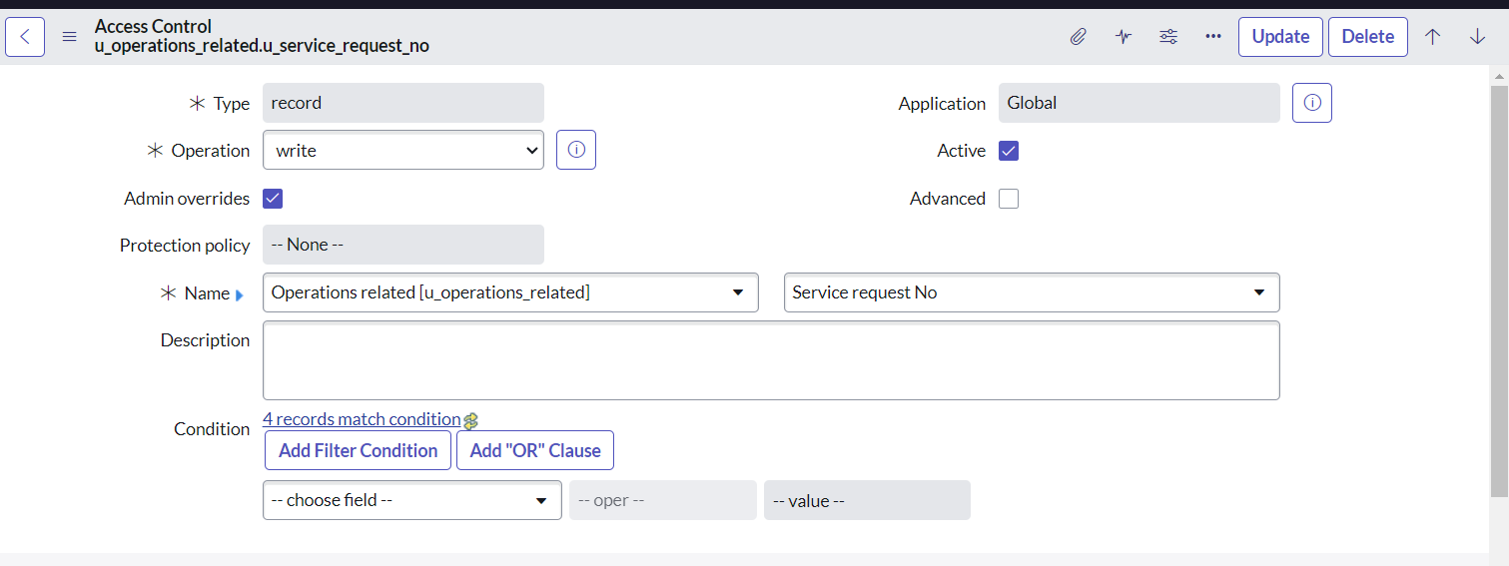
- Fill the following details to create a new ACL

- Scroll down under requires role
- Double click on insert a new row
- Give admin role
- Click on submit
- Similarly create 4 acl for the following fields

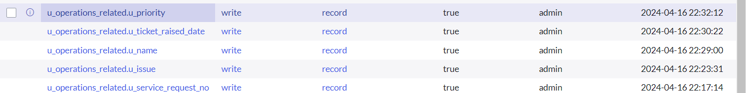

Flow
A Flow is created in Flow Designer to automate ticket assignment based on the Issue field in the Operations Related table. The flow triggers when a record is created or updated and evaluates the selected issue type. Based on predefined conditions, the system automatically assigns the ticket to either the Certificates or Platform group, eliminating manual routing and improving operational efficiency.

Create a Flow to Assign operations ticket to group
- Open service now.
- Click on All >> search for Flow Designer
- Click on Flow Designer under Process Automation.
- After opening Flow Designer Click on new and select Flow.
- Under Flow properties Give Flow Name as “ Regarding Certificate”.
- Application should be Global.
- Select Run user as “ System user ” from that choice.
- Click on Submit.

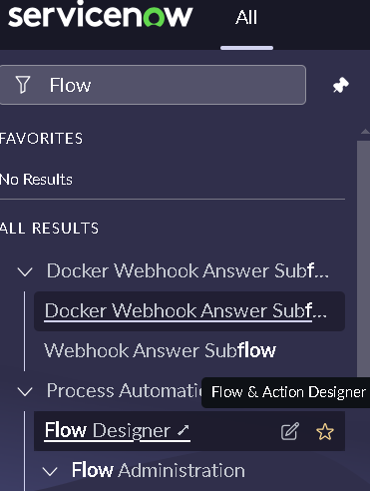

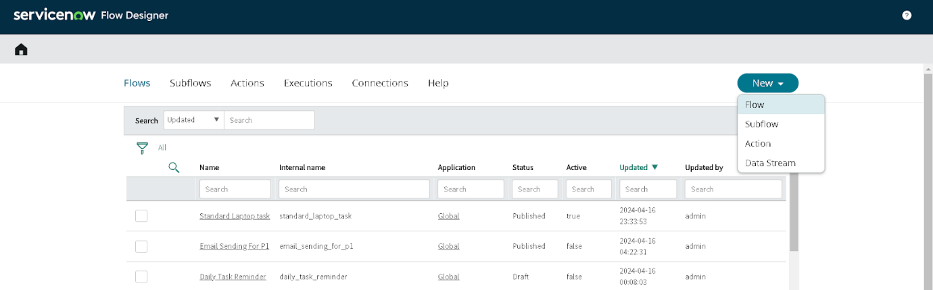

- Click on Add a trigger
- Select the trigger in that Search for “create or update a record” and select that.
- Give the table name as “ Operations related ”.
- Give the Condition as
Field : issue
- Operator : is
- Value : Regrading Certificates
- After that click on Done.
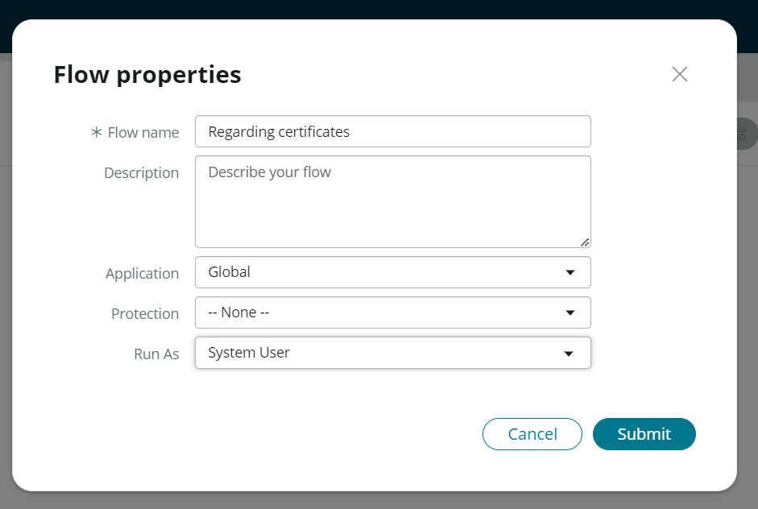

- Now under Actions.
- Click on Add an action.
- Select action in that search for “ Update Record ”.
- In Record field drag the fields from the data navigation from left side
- Table will be auto assigned after that
- Give the field as “ Assigned to group ”
- Give value as “ Certificates ”
- Click on Done.
- Click on Save to save the Flow.
- Click on Activate.

Create a Flow to Assign operations ticket to Platform group

- Open service now.
- Click on All >> search for Flow Designer
- Click on Flow Designer under Process Automation.
- After opening Flow Designer Click on new and select Flow.
- Under Flow properties Give Flow Name as “ Regarding Platform ”.
- Application should be Global.
- Select Run user as “ System user ” from that choice.
- Click on Submit.
- Click on Add a trigger
- Select the trigger in that Search for “create or update a record” and select that.
- Give the table name as “ Operations related ”.
- Give the Condition as
Field : issue
- Operator : is
- Value : Unable to login to platform
- Click on New Criteria
- Field : issue
- Operator : is
- Value : 404 Error
- Click on New Criteria
- Field : issue
- Operator : is
- Value : Regrading User expired
- After that click on Done.
- Now under Actions.
- Click on Add an action.
- Select action in that search for “ Update Record ”.
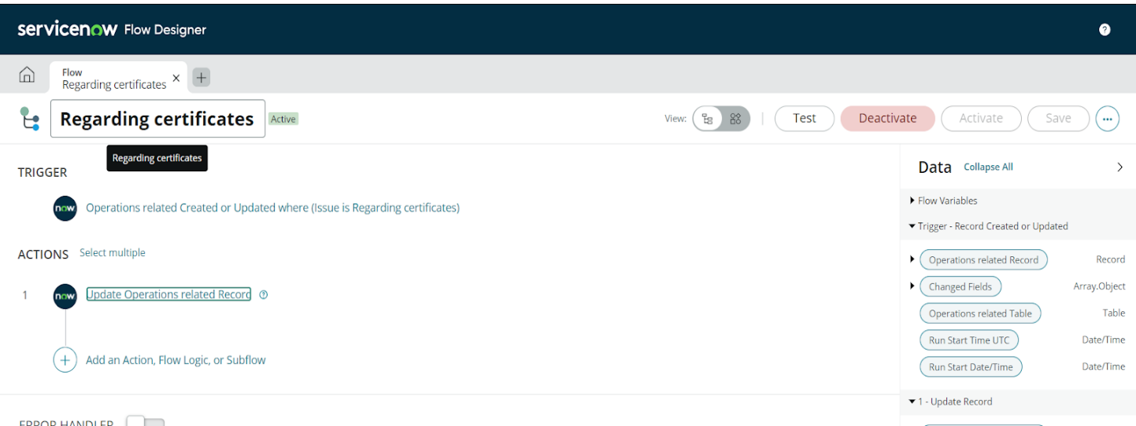

- In Record field drag the fields from the data navigation from left side
- Table will be auto assigned after that
- Give the field as “ Assigned to group ”.
- Give value as “ Platform ”.
- Click on Done.
- Click on Save to save the Flow.
- Click on Activate.

Conclusion
The implementation of the automated ticket routing system at ABC Corporation has been a significant success. By leveraging the capabilities of ServiceNow, we have streamlined the process of assigning support tickets to the appropriate teams, addressing the challenges of manual routing, and ensuring timely resolution of issues.

